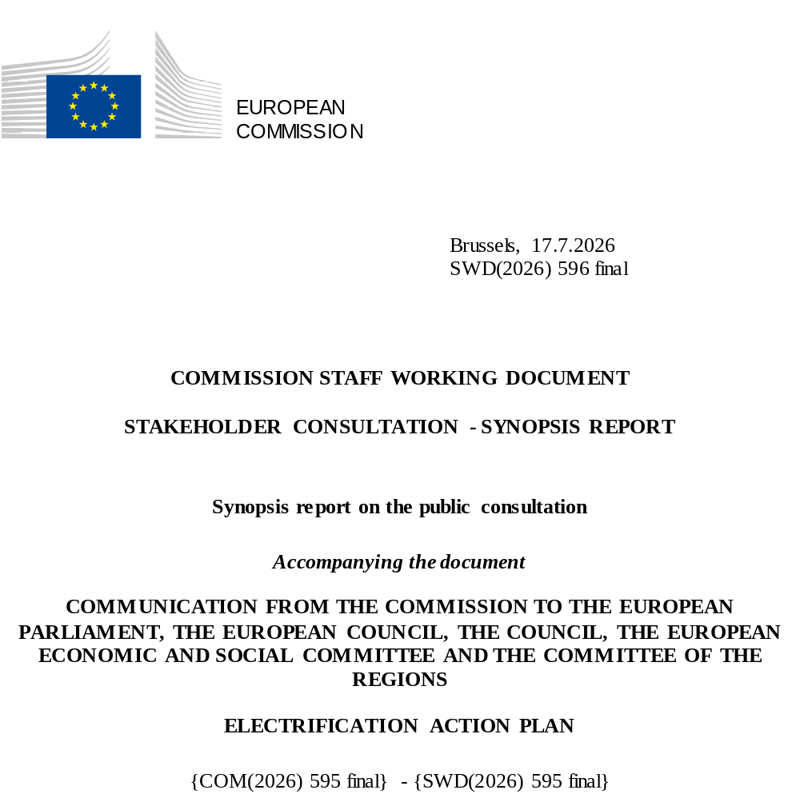

1. Introduction
The Electrification Action Plan was announced as a deliverable in the Affordable Energy Action Plan, with the objective of accelerating the electrification of energy demand across sectors, as a key enabler of decarbonisation, competitiveness and energy security.
In preparation of this initiative, the Commission carried out a broad stakeholder consultation, consisting of an open public consultation and a call for evidence, both published on the Commission’s “Have your Say” portal. The consultation aimed at gathering views from citizens, stakeholders and public authorities on the objectives, barriers and policy options for accelerating electrification across the energy system.
This document should be regarded solely as a summary of the contributions made by stakeholders through this consultation process. It cannot in any circumstances be regarded as the official position of the Commission or its services and thus it is not binding for the Commission. Responses to the consultation activities cannot be considered as a representative sample of the views of the EU population.

2. Scope of the consultation and participation

Open Public consultation
The public consultation questionnaire included a combination of multiple-choice, ranking and open-ended questions covering:
- the objectives of an EU Electrification Action Plan,
- barriers to electrification across sectors,
- policy options to accelerate electrification,
- flexibility, storage and demand response,
- sector-specific aspects, including for transport and heating and cooling.
The Commission received 320 contributions. Business associations represented the largest group of respondents (115), followed by companies and businesses (109). EU citizens accounted for 33 submissions, while non-governmental organisations (28) also contributed significantly to the consultation.

Call for evidence
The call for evidence allowed stakeholders to provide free-text feedback and submit position papers on the scope and content of the Electrification Action Plan, including barriers, policy priorities and cross-cutting considerations.
The Commission received 177 contributions from individuals and organisations.
The largest group of respondents was business associations (80), followed by companies/businesses (44) and EU citizens (22). Additional contributions were received from non-governmental organisations (16) and other stakeholders (7), among others.

3. Tools and methodology
A quantitative and qualitative analysis of the replies to the public consultation and the comments received to the call for evidence was carried out. The replies to the multiple-choice questions in the public consultation were processed using the quantitative data analysis tools in EU Survey. The qualitative replies (the free text replies to the questions as well as the attached position papers) were gathered and screened separately from the quantitative data. The comments to the call for evidence were classified according to the claims made and quantified.

4. Results of the Open Public Consultation
The public consultation questionnaire was structured around four main parts:
- Part 1 covered cross-sectoral issues related to the Electrification Action Plan, including its objectives, barriers to electrification across sectors, and priority policy options.
- Part 2 focused on system flexibility, addressing the relevance of demand response and storage technologies, the main barriers to their deployment, and related policy options.
- Part 3 examined the electrification of transport, covering preferred decarbonisation pathways, sector-specific barriers (including road, rail and maritime transport), and policy measures to accelerate deployment.
- Part 4 addressed the electrification of heating and cooling in buildings and industry, including relevant technologies, key barriers for different building types and industrial processes, and policy options related to regulatory frameworks, system design, financing, affordability and consumer empowerment.

4.1 Objectives of an EU Electrification Action Plan
When asked about the general objectives of an EU Electrification Action Plan, respondents most frequently selected decarbonisation (89 responses) and competitiveness (88) as priority objectives. Energy security was also selected by a significant number of respondents (52).
Energy affordability was selected by 41 respondents, while energy efficiency (27), environmental protection (8) and fairness, consumer protection and empowerment (2) were selected less frequently. Other objectives were mentioned by 13 respondents.

4.2 Cross-sector barriers to electrification
Across all sectors, the barrier selected by the largest number of respondents was high upfront transition costs for the electrification of end-uses (205), clearly standing out from all other options.
This was followed by insufficient electricity grid capacity (141), length and complexity of administrative and permitting procedures (119), and high upfront costs or delays to connect to the grid (113).
Price-related barriers were also frequently cited, including unfavourable tax treatment of electricity compared to fossil fuels (99), unfavourable retail price ratios (89), and uncertainty about future electricity prices compared to fossil fuels (86).
Other barriers, such as insufficient policy signals (69), high network tariffs (70) and weak implementation of the current regulatory framework (63) were selected less frequently.

4.3 Policy options to accelerate electrification of energy demand
EU policy framework
Within the EU policy framework, respondents most frequently selected additional public financing (182) and implementation of the current EU regulatory framework (180). These options received significantly more support than adaptation of the current legislative framework towards 2030 (105) or the introduction of a new legislative framework towards 2040 (82).
General policy design measures
The most frequently selected policy design measures were accelerating and simplifying permitting procedures (173) and revising energy taxation in favour of electricity (149), followed by removing non-energy related costs from electricity bills (124). Other measures, such as adopting EU targets for electrification (87) or for non-fossil flexibility (49), were selected less frequently.
Access to grid and flexibility
Regarding access to the grid and flexibility, respondents most frequently selected increasing grid capacity (167) and enabling timely grid connections (133). Network tariffs promoting flexibility (122) and improving access to participation and remuneration of flexibility services (106) were also selected by a substantial number of respondents.
Financing and investment
The highest number of selections was recorded for increasing the availability of financial instruments to cover upfront costs (210), followed by providing public grants or loans, including EU funds, to leverage private investment (191) and measures promoting access to renewable electricity, including through PPAs (167).

4.4 Flexibility, demand response and storage
Barriers to demand response
The most frequently cited barriers to demand response were administrative and regulatory barriers (157), lack of remuneration for the provision of services (143) and high initial investment costs (129). Insufficient awareness or trust in solutions (116) and insufficient digitalisation (114) were also selected by a high number of respondents.
Barriers to storage deployment
For storage solutions, respondents most frequently identified high initial investment costs (174) and grid connection constraints (162) as barriers. These were followed by administrative and regulatory barriers (137) and lengthy permitting procedures (109). Double taxation for storage (101) and lack of remuneration for services (96) were also selected by a significant number of respondents.
Policy options for increasing system flexibility
The most frequently selected policy option was effective implementation of the current EU regulatory framework (182), followed by additional public financing (137). Among policy design measures, promoting digitalisation and data sharing (191) and accelerating and simplifying permitting procedures for storage (186) received the highest number of selections. Facilitating grid connection for flexibility assets (195) was the most selected option under access to grid and flexibility.

4.5 Electrification of transport
For electric light-duty vehicles, the most frequently cited barriers were lack of financial incentives (73), difficulties in securing an appropriate grid connection (66) and complex permitting procedures for the installation of recharging points (60). Lack of awareness and behavioural resistance was also selected by a high number of respondents (70).
By contrast, low technological maturity (14), lack of interoperability (16), lack of access to markets for small and mobile assets (14) and vehicle-to-grid metering issues (21) were among the least selected barriers.

4.6 Electrification of heating and cooling
Across residential and non-residential buildings, high initial investment costs were the most frequently selected barrier (157 for individual dwellings, 150 for apartment buildings, and 147 for non-residential buildings).
This was followed by infrastructure-related barriers (64–85 selections depending on building type), high financing and operational costs, and insufficient awareness or trust in solutions.
By contrast, technical barriers, skills-related barriers, and lack of fit-for-purpose technologies were selected by a comparatively lower number of respondents across all building categories.
Regarding policy options, respondents most frequently selected additional public financing and implementation of the current EU regulatory framework for both space heating and industrial processes. Faster and simpler permitting procedures received particularly high support for industrial applications (115 selections). Under affordability and just transition, protection of energy-poor and vulnerable consumers (119) was most frequently selected for space heating, while support for demonstration projects (102) and support for skills (85) were most frequently selected for industrial processes.

5. Results of the Call for Evidence
The call for evidence shows broad and consistent support among respondents for accelerating electrification as a central pillar of the EU’s energy policies. Contributions widely highlighted electrification as a key enabler for reducing greenhouse gas emissions, decreasing dependence on imported fossil fuels and strengthening the competitiveness and resilience of European industry. This overall support was shared across stakeholder groups, although views diverged on the future role of gas-based solutions and renewable gases in heating and energy systems.
A significant number of contributions pointed to economic, regulatory and structural barriers slowing down electrification. Respondents frequently referred to unfavourable cost structures, including high upfront investment costs, electricity taxation and network charges, as well as an insufficiently levelled electricity-to-gas price ratio. Grid capacity constraints, lengthy and complex permitting procedures and administrative burdens were also repeatedly identified as major bottlenecks. In addition, many stakeholders underlined that unclear, fragmented or unstable policy frameworks increase investment risk and hinder long-term planning.
Respondents consistently stressed the need to prioritise the effective implementation and enforcement of existing EU legislation, rather than introducing additional frameworks. Many contributions called for faster and simpler permitting procedures, greater regulatory coherence across Member States and clearer long-term policy signals to support investment decisions. Enhanced public and private financing, including de-risking instruments, innovative business models and targeted use of EU funds, were also frequently highlighted as necessary to accelerate deployment.
Electrification was often linked to the broader transformation of the energy system. Many respondents emphasised the importance of integrating electrification with the deployment of renewable energy, demand-side flexibility and storage, as well as with integrated planning across electricity, heating and gas networks. Several contributions underlined that flexibility, dynamic tariffs and smarter grids are essential to manage rising electricity demand efficiently and to reduce overall system costs.
Furthermore, beyond technical and economic aspects, a great deal of respondents stressed the importance of affordability, skills development and social considerations. Contributions highlighted workforce shortages as a growing challenge and called for stronger EU-level support for training and upskilling. Ensuring consumer protection, fair cost distribution and public acceptance was seen as crucial to securing a just and socially balanced transition.
Overall, the call for evidence largely reinforces and complements the messages emerging from the public consultation, confirming strong support for electrification while also highlighting key implementation challenges and areas of divergence.

6. Stakeholder events
In the framework of the public consultation different events were organized in 2025 to gather additional inputs and exchange views with stakeholders. On 21-22 October an online workshop on electrification with think tanks and academics was held, with the first day focusing on horizontal barriers and the buildings sector, while on the second day electrification of transport and industry was at the centre of the debate. More than 20 think tanks attended the two-days’ workshop providing policy inputs based on their recent research on electrification. The horizontal session made the case for EU electrification for energy security, diving into affordability and benefits for households and industry. The horizontal barriers and the technical electrification potential for the different demand sectors were presented as well, while the sectorial barriers and opportunities were addressed in the following sessions on buildings, transport and industry.
A stakeholder meeting was organised on November 7 and sparked significant interest, drawing over 70 in-person attendees and more than 300 online participants, reflecting the substantial engagement and importance of the topic which was portrayed as a core priority for security of supply, energy efficiency, affordability and decarbonisation. At the meeting sector associations, non-profit organizations, and industry representatives provided input on the barriers that hinder further electrification expressing large consensus on the need to reduce the price ratio between electricity and gas via taxes and levies. The importance of de-risking instruments, flexibility, permitting and access to grids was highlighted in the horizontal session. Similar barriers were outlined in the industrial electrification session, where the need to focus on sectors that offer immediate opportunities for electrification, heat as a service and other innovative business models or network charges that incentivize flexibility were highlighted. In the transport session a large consensus was expressed on the need for policy certainty, and the need to incentivise solutions like smart charging and vehicle to grids.
On November 21, a final stakeholder event was organized in the form of an online workshop with industrial consumers, with around 50 participants representing a wide range of industrial sectors, such as food and drinks, metals including aluminium, iron and steel, pulp and paper, glass manufacturing, the chemical sector, and more. Beyond industry, the flexibility and electricity supply sectors were also represented. Two sessions shed light first on available technologies and economic potential of electrification, where low temperature heat was depicted as having the highest potential with existing technologies, and examples of cost-effective business models for electrification were presented. Then, the focus was on the potential for industrial flexibility, and the technical potential revenues that can be generated from demand flexibility were described for five energy-intensive industries, and stakeholders highlighted the importance of the right price signals and possible support schemes to deploy industrial demand flexibility.

7. Conclusions
The open public consultation and the call for evidence results show strong and consistent support and commitment for accelerating electrification across different sectors as a central pillar of the EU’s energy transition. Stakeholders clearly prioritise investment affordability, grid readiness, regulatory simplification and effective implementation of existing frameworks.
The findings highlight the need for a coherent and integrated Electrification Action Plan combining implementation of the current EU framework, attention to upfront costs, flexibility, social considerations and market design to unlock the full potential of electrification in support of the EU’s climate, competitiveness and energy security objectives.

